Recording a Peer Support of Teaching Session

The new Peer Support of Teaching reporting system is available to all staff from myadmin.aber.ac.uk.
Guidance on how to carry out the peer support session can be found on the Learning and Teaching Enhancement Unit website. This page includes a form that can be downloaded and used to record the conversation / observation.
After you have completed your conversation / observation, the person supporting should record some information in the Peer Support of Teaching reporting system. You will need to record:
- Date of conversation / observation
- Module
- Areas of good practice

To record a conversation / observation
- Login to peer Support of Teaching from myadmin.aber.ac.uk.
- If you are recording details from off-campus you must sign into VPN first (https://www.aber.ac.uk/en/is/it-services/vpn/)

If a record has already been created for you
- Under My Peer Support Sessions, click on the pencil icon on the far left-hand side of the relevant record
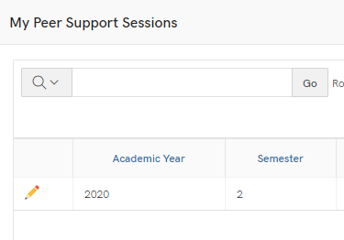
- Check any details already added, and complete any fields that haven’t already been filled in (e.g. date and module code)
- Type your good practice comments
- Change the drop-down menu to Complete
- Press Apply Changes
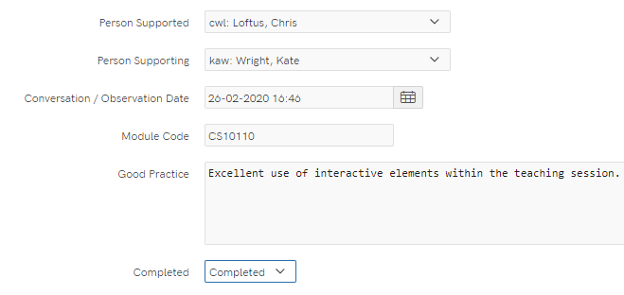

If a record has not been created for you
- Find the person you are supporting in the list of Available Peer Support Sessions
- Click on the pencil icon next to their name
- Complete the form with your own name as the Person Supporting
- Select the date of your conversation / observation
- Enter the module code
- Complete the details of good practice
- Change the dropdown menu to Completed
- Press Apply Changes

To set-up sessions on behalf of others
If you are creating the peer support sessions on behalf of others:
- In the list of Available Peer Support Sessions, click on the pencil icon next to the name of a staff member
- In the Person Supporting dropdown list, select the person who will be supporting / observing the staff member
- If you know the date of the session or which module you can enter this. Alternatively, you can leave it blank and it can be completed after the conversation / observation.
- Press Apply Changes

