Adapted from “great ideas for teaching marketing”

KFC flavour nail polish? A brand extension too far..?

In an increasing attempt to resonate with emergent consumers KFC has selectively introduced a chicken flavoured nail polish to the Hong Kong market.

According to their publicity “this campaign is designed to be intriguing and fun to increase excitement around the KFC brand in Hong Kong”.

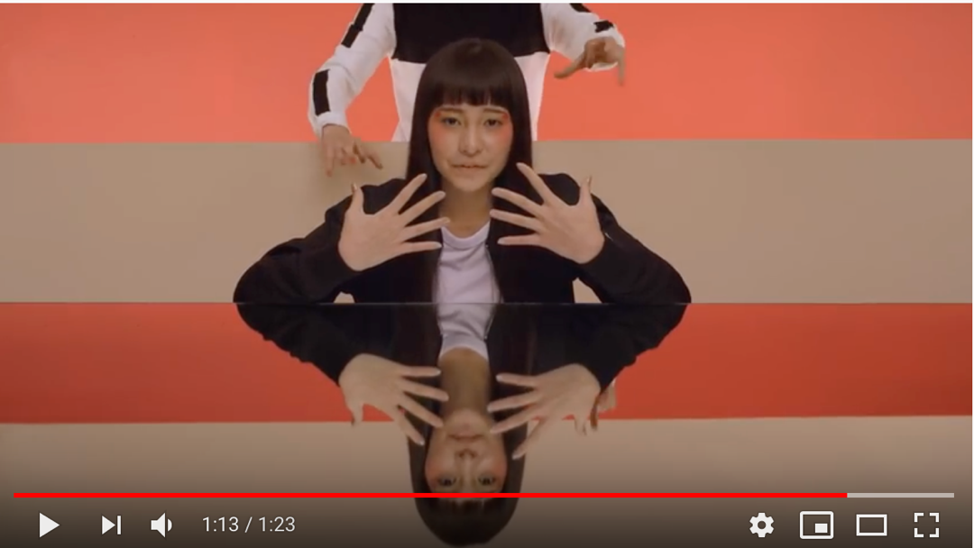

(click the image to open the YouTube video)

- Argue for and against the concept of Emotional and Unique Selling Proposition for the example above.

- Either individually or in groups discuss evidence from this brand activation as to whether you believe KFC is (after Aaker 1997)

  - Sincere, Exciting, Competent, Sophisticated or Rugged?

- Kotler et al 2009 outlined four levels of meaning for brand identify, that of
Attributes, Benefits, Values, Personality

  - How do you think this advert may have impacted those four levels?

- This is a brand extension for KFC (possibly purely done for promotional purposes), can you identify other areas in which KFC might extend their brand?

