Learn how vaccines help fight the coronavirus

Short description: It’s been a year now since a new virus has been discovered and our lives have changed. For a long time it seemed like we would have to quarantine for a very long time, however, a spark of hope was ignited when the first vaccine was approved. There are three vaccines currently being distributed in Europe and the number of vaccinated people is growing steadily, but how do vaccines really work against the coronavirus?
Question: Which blood cells are responsible for making antibodies that fight diseases?

Activities:
Like human faces, all cells have unique features. This helps the white blood cells, lymphocytes, recognize cells that inhabit our body, like we would a friend. If they don’t recognize the cell, the lymphocytes release antibodies designed to kill them. However, as our bodies have never encountered COVID-19 before, by the time they produce the antibodies most people are already sick. Vaccines use the weakened virus to help the white blood produce antibodies without making you ill, so that they can kill the live virus without causing illness. This works because once the antibodies are produced, they also produce memory cells so your body can react quicker next time.
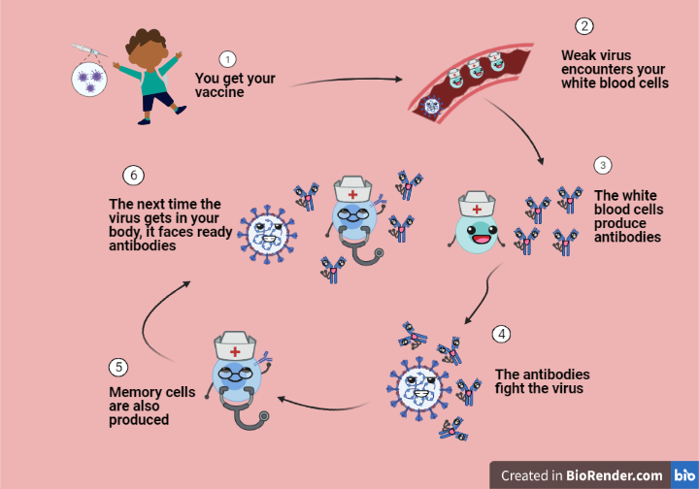

Take a look at this video explaining that process: https://www.youtube.com/watch?v=5SproXmRUkI&t=121s&ab_channel=SciShowKids

I think you are ready now to help our white blood cell fight the evil virus!
Simply click on the link below and follow the instructions below the game, good luck!
https://flowlab.io/game/play/1622038

