How do plants get their colour?

Have you ever wondered what gives plants their different colours?
This experiment will help you figure out!

You will need:
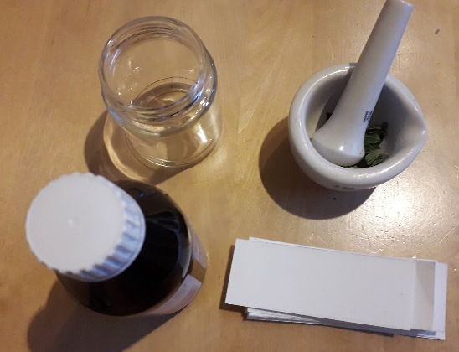
-Leaves and/or flowers of different colours
- Isopropyl alcohol (or methylated spirit)
- Mortar and pestle (or bowl and spoon)
- Small jars
- Scissors
- Filter paper (or coffee filters)

What to do:
- Collect leaves and flowers of different colours, the brighter and more varied the better.
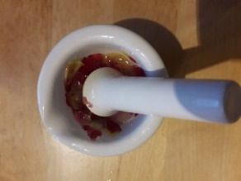
- Cut the leaves and flowers into small pieces and using a mortar and pestle crush them to release all the juices. If you do not have a mortar and pestle, use a bowl and the back of a spoon to crush the plants.

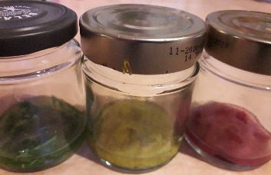
- Transfer the leaves to a small clear jar and add enough alcohol to cover them. Isopropyl alcohol and methylated spirit work wellbut any other solution with 70% or higher alcohol will also work.

- Close the jar and wait for at least 2h or keep in the fridge until the next day.

- Take the jars out of the fridge. The liquid should have turned the colour of the leaves or flowers you put in.

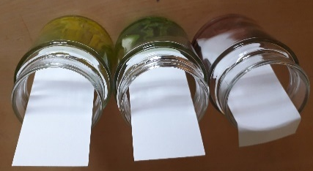
- Cut filter paper (coffee filters or highly absorbent kitchen paper will also work) into strips. They need to fit into the jar with about 2-3cm sticking out.

- Open the jar and put the filter paper in so it touches the liquid.

- Wait for around 2h, or until you see the different colours appear as lines on the filter paper.
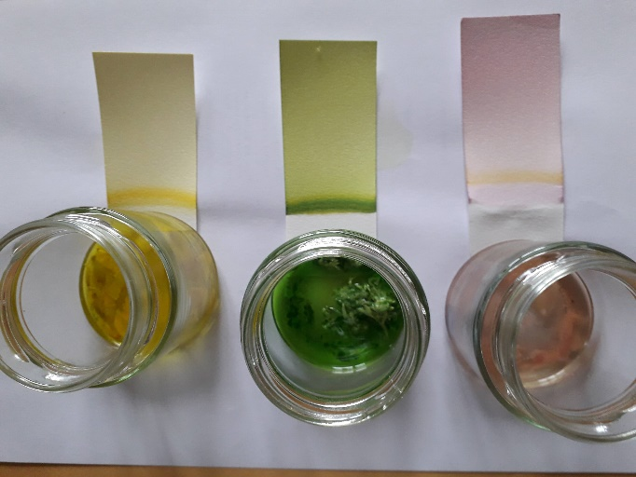

What happened?
Plants have three major types of pigments, Chlorophylls, Carotenoids and Anthocyanins.
Chlorophylls are the major pigments involved in photosynthesis, the process by which plants convert light energy from the sun into food. Chlorophylls are responsible for the green colour of the plant.
Carotenoids also function during photosynthesis and they protect the plant against strong light. They give the plant yellow and orange colours.
Anthocyanins, give plants their red and purple colour. They have important functions during photosynthesis and protect the plant against stresses.

The colour of a given stem, leaf and flower depends on the amounts of each of these pigments. When you crush the leaves, the pigments are released into the alcohol. When passing through the filter paper these pigments are separated by a process called chromatography and the different pigment bands (green, yellow, red) can be separated.

